Status of implementation of the INSPIRE Directive – 2024 Country Fiches

COUNTRY FICHE Slovakia

1. State of Play 1
1.1 Coordination 1
1.2 Functioning and coordination of the infrastructure 2
1.3 Usage of the infrastructure for spatial information 4
1.4 Data Sharing Arrangements 5
1.5 Costs and Benefits 5

1. State of Play

1.1 Coordination
- National Contact point
Member State Contact Point
Name of the public authority | Ministry of Environment of the Slovak Republic
Contact information:
Mailing address | Tajovského 28, 975 90 Banská Bystrica
Telephone number | +421 48 4374 523
Telefax number
Email address | inspire@enviro.gov.sk
Organisation’s website URL | https://www.minzp.sk , https://inspire.gov.sk
Contact person (if available) | Ing. Martin Tuchyňa, PhD.
Telephone number | +421 48 4374 523
Email address | martin.tuchyna@enviro.gov.sk
Contact person - substitute (if available) | Ing. Martin Koška
Telephone number | +421 48 4374 522
Email address | martin.koska@enviro.gov.sk
- Coordination Structure
  - Coordination of the relevant stakeholders in Slovakia is facilitated on two main levels:
    - Strategy / Main public sector stakeholders’ level represented by Coordination Committee of National Spatial Data Infrastructure (NSDI Council / KR-NIPI)
    - Technical / implementation level represented by Expert Group of NSDI (NSDI Expert Group / ES NIPI). The ES NIPI coordinates the work of ad hoc Technical Working Groups).
    - Based on experience the plan is to merge KR and ES NIPI into the one joint Coordination group (Figure 1.).
  - Main responsibility for the INSPIRE implementation and coordination was assigned to the Ministry of Environment of the Slovak Republic (MoE), supported with the Coordination Council (KR NIPI). KR NIPI is representing the main central public authorities, including the representation of local governance.
  - Ministry of Environment of the Slovak Republic is also in charge of National Geoportal, Spatial Data Registry as well as National INSPIRE website maintenance, communication with the Slovakian stakeholders, communication with European Commission, and provides the primary contacts in both Maintenance and Implementation Groups (MIG) political and technical.
  - From the 2020 INSPIRE implementation process is supported with the NSDI Data Office, established with the mission to ensure support for the coordination of the establishment and maintenance of NSDI, including utilising the activities of national ESPUS project.
  - During the year 2023, coordination with Open Data / HVD community has continued. Main responsibility for the eGov / Open Data agenda remains with Ministry of investment, regional development and informatization of the Slovak Republic (MIRRI) (Figure 1.).

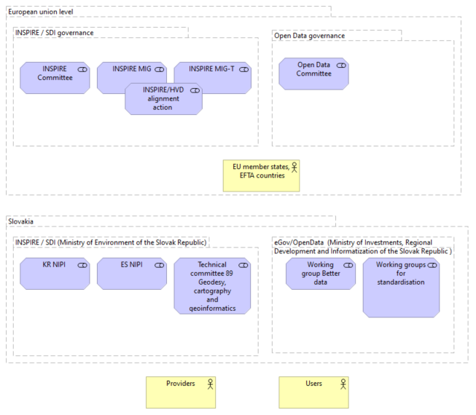
Figure1: Overview of the Slovakian NSDI coordination

- Progress
  - INSPIRE in Slovakia during the 2023 was mainly focused on update of main infrastructure components, strengthen the availability of INSPIRE resources, alignment with Open Data / High value datasets efforts and improvement of monitoring of the infrastructure.

  - New version of the National Geoportal, Spatial Data Registry as well as National INSPIRE website were launched during the 2023 in order to support coordination on central level.
  - Revision and validation of the INSPIRE resources took place in order to ensure proper linkages and improve performance towards the INSPIRE monitoring.
  - First joint INSPIRE and Copernicus Czech and Slovak conference was organised with intention to create synergies and strengthen knowledge transfer.
  - Main challenges remains with the conformity of spatial data sets towards the requirements for interoperability as well as with the conformity of some types of network services. Complexity of the INSPIRE requirements as well as limited capacities on the side of data providers still creates significant limitations. This is remains even more tangible towards the regional and local SDIs.

1.2 Functioning and coordination of the infrastructure
- Coordination of the NSDI during the 2023 took place as via joined NSDI council and NSDI Expert Group meetings, GitLab collaborative platform as well as via direct communication with the stakeholders.
- In connection the results of the INSPIRE monitoring 2023, there has been substantial increase in most of the monitored indicators, thanks to provision of the guidance and support to stakeholders and their commitment.
- Although overall amount of metadata records has decreased comparing previous year (via applying the filter selecting only INSPIRE resources) majority of the monitored indicators resulted with increased results.
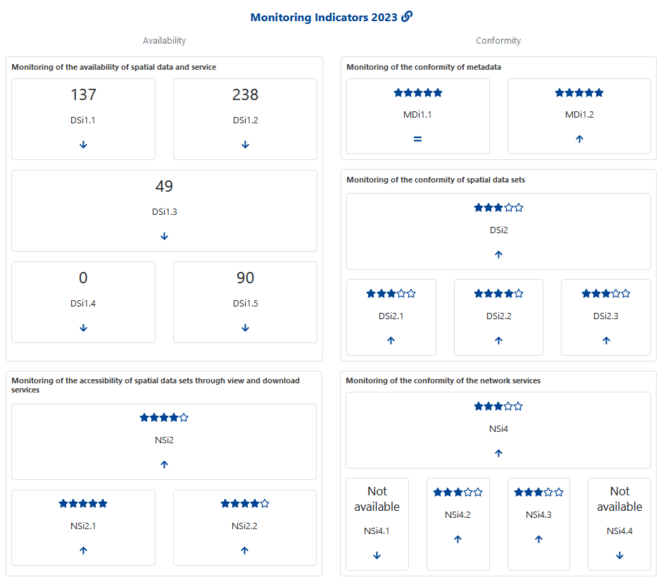
Figure 2: INSPIRE monitoring indicators 2023 - Slovakia (Source INSPIRE Geoportal)

- Comparing the results of INSPRIE monitoring from 2022, most significant progress has been achieved in the area of services metadata conformance and accessibility of the datasets via view and download services.
- Not negligible improvements are also visible in the area of the conformity for spatial data sets interoperability, as well as conformity of the network services.

1.3 Usage of the infrastructure for spatial information
- Usage of the infrastructure remains still quite challenge, as there are mainly indirect indicators providing related information. Google analytics statistics related to the INSPIRE related websites for 2023:
  - geoportal.gov.sk: 6,3k users, 74k events;
  - rpi.gov.sk: 529, 6,8k events;
  - inspire.gov.sk: 601 users, 9k events.

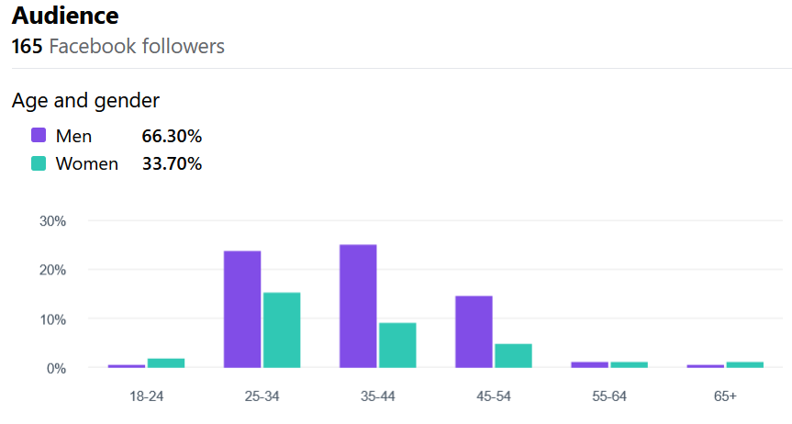
Figure 4: inspire.gov.sk Facebook page audience (Source: https://www.facebook.com/inspiresk)

- Monitoring of the selected INSPIRE services has started initially with the focus on the service availability.

1.4 Data Sharing Arrangements
- Most of the INSPIRE datasets has been made available under the open data licence limiting possible restrictions for the further re-use. Some exceptions remains.
- Adoption of HVD regulation contributed to the further discussion about the geospatial datasets to be made available under Open Data license and in synergy with INSPIRE.
- Full integration with SK national Open Data portal is still under the discussion with the Ministry of Investments, Regional Development and Informatization of the Slovak Republic.

1.5 Costs and Benefits
- The cost and benefits evaluation is based on the information collected in the structured tabular information from the representatives of the relevant stakeholders.
- The total indicative costs related with the INSPIRE implementation for 2023: 340 513 € and 225 person days.
- From the Benefits perspective, these were identified mainly in for of
  - Fulfilment of INSPIRE and environmental legal requirements
  - Strengthening of the discoverability of spatial data
  - Spatial data accessibility improvement
  - Uniform access to spatial data (priority/harmonized datasets)
  - More efficient management and functionality of internal spatial data and services
  - Increasing pressure on the quality of spatial data and services and their documentation with metadata
  - INSPIRE monitoring results improvements on behalf of the Slovakia
  - Increased potential for digital spatial content and functionality re-use
  - Strengthening communication with external domains and communities
  - Raising awareness of the potential of spatial data and services
  - Synergies strengthen between with Open data and HVD activities
  - Improved availability of spatial data via standardised services
  - Increased overview and transparency of the spatial data and services managed by Public Health Authority of the Slovak Republic
  - Increased potential for usability of spatial data for Public Health Authority of the Slovak Republic and other stakeholders
  - Highlighting the need to increase capacity and financial resources to ensure INSPIRE requirements

- Detailed information about the costs and benefits can be accessed via this summary table. Details, based on the information provided by the organisations.

