Status of implementation of the INSPIRE Directive – 2023 Country Fiches

COUNTRY FICHE Slovakia 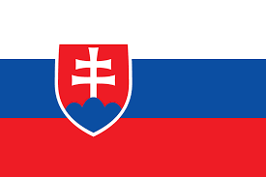

1. State of Play 1
1.1 Coordination 1
1.2 Functioning and coordination of the infrastructure 2
1.3 Usage of the infrastructure for spatial information 4
1.4 Data Sharing Arrangements 5
1.5 Costs and Benefits 5

1. State of Play

1.1 Coordination
- National Contact point
Member State Contact Point
Name of the public authority | Ministry of Environment of the Slovak Republic
Contact information:
Mailing address | Tajovského 28, 975 90 Banská Bystrica
Telephone number | +421 48 4374 523
Telefax number
Email address | inspire@enviro.gov.sk
Organisation’s website URL | https://www.minzp.sk , https://inspire.gov.sk
Contact person (if available) | Ing. Martin Tuchyňa, PhD.
Telephone number | +421 48 4374 523
Email address | martin.tuchyna@enviro.gov.sk
Contact person - substitute (if available) | Ing. Martin Koška
Telephone number | +421 48 4374 522
Email address | martin.koska@enviro.gov.sk
- Coordination Structure
  - Coordination of the relevant stakeholders in Slovakia is facilitated on two main levels:
    - Strategy / Main public sector stakeholders’ level represented by Coordination Committee of National Spatial Data Infrastructure (NSDI Council / KR-NIPI)
    - Technical / implementation level represented by Expert Group of NSDI (NSDI Expert Group / ES NIPI). The ES NIPI coordinates the work of ad hoc Technical Working Groups).
    - Based on experience the plan is to merge KR and ES NIPI into the one joint Coordination group (Figure 1.).
  - Main responsibility for the INSPIRE implementation and coordination was assigned to the Ministry of Environment of the Slovak Republic (MoE), supported with the Coordination Council (KR NIPI). KR NIPI is representing the main central public authorities, including the representation of local governance.
  - Ministry of Environment of the Slovak Republic is also in charge of National Geoportal, Spatial Data Registry as well as National INSPIRE website maintenance, communication with the Slovakian stakeholders, communication with European Commission, and provides the primary contacts in both Maintenance and Implementation Groups (MIG) political and technical.
  - From the 2020 INSPIRE implementation process is supported with the NSDI Data Office, established with the mission to ensure support for the coordination of the establishment and maintenance of NSDI, including utilising the activities of national ESPUS project.
  - By the end of the 2022, initial efforts for coordination with Open Data / HVD community has started. Main responsibility for the eGov / Open Data agenda remains with Ministry of investment, regional development and informatization of the Slovak Republic (MIRRI) (Figure 1.).

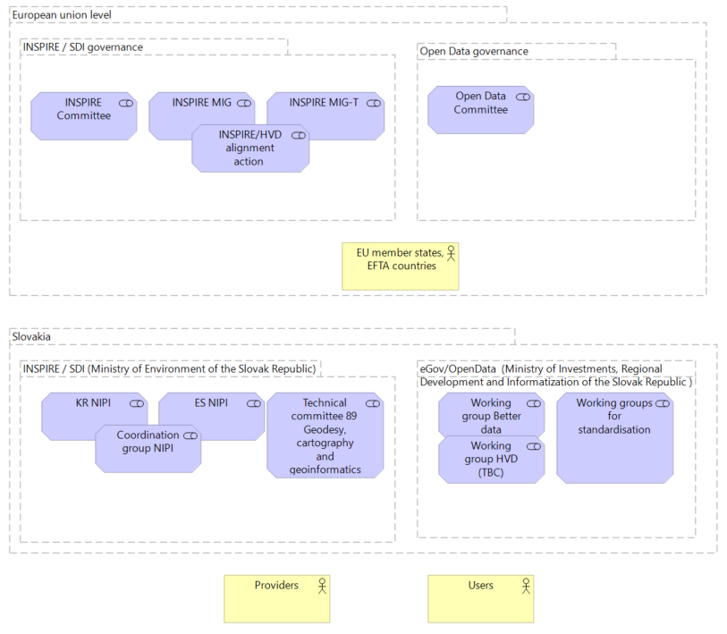
Figure1: Overview of the Slovakian NSDI coordination

- Progress
  - In summary, INSPIRE implementation and maintenance in Slovakia during 2022 mainly focused on strengthen of awareness raising and Annex III datasets availability. At the same time initial efforts to establish synergy with Open Data / HVD community has started, too.
  - In connection to the awareness raising, 2 conferences (one online and one physical), 8 worskhops and 25 trainings were organised with the support of the ESPUS project aiming to promote SDI, identify potential and challenges and create connections to other domains.
  - In the domain of interoperability, new INSPIRE annex III datasets has been identified and made available.
  - At the same time, developments of versions of National Geoportal, Spatial Data Registry as well as National INSPIRE website took place with the plan to get operational during the 2023.
  - Main challenges remains with the conformity of spatial data sets as well as with the conformity of some types of network services. Complexity of the INSPIRE requirements as well as limited capacities on the side of data providers still creates significant limitations. This is even more tangible towards the regional and local SDIs.

1.2 Functioning and coordination of the infrastructure
- Coordination of the NSDI during the 2022 took place as via NSDI council and NSDI Expert Group meetings, as well as via above mentioned ESPUS specific events and direct communication with the stakeholders. In order to support further coordination and reflect the changes, taking place on European level, Methodical framework for an effective management and monitoring of spatial data and services has been prepared.
- In connection the results of the INSPIRE monitoring 2022, there has been substantial increase in metadata availability as for datasets as well as for services, comparing previous year.
- Concerning the conformance of the metadata, although in case of dataset metadata conformance, new 59 conformant results was documented, surprisingly in case of service metadata increased amount of non-conformant records was identified.
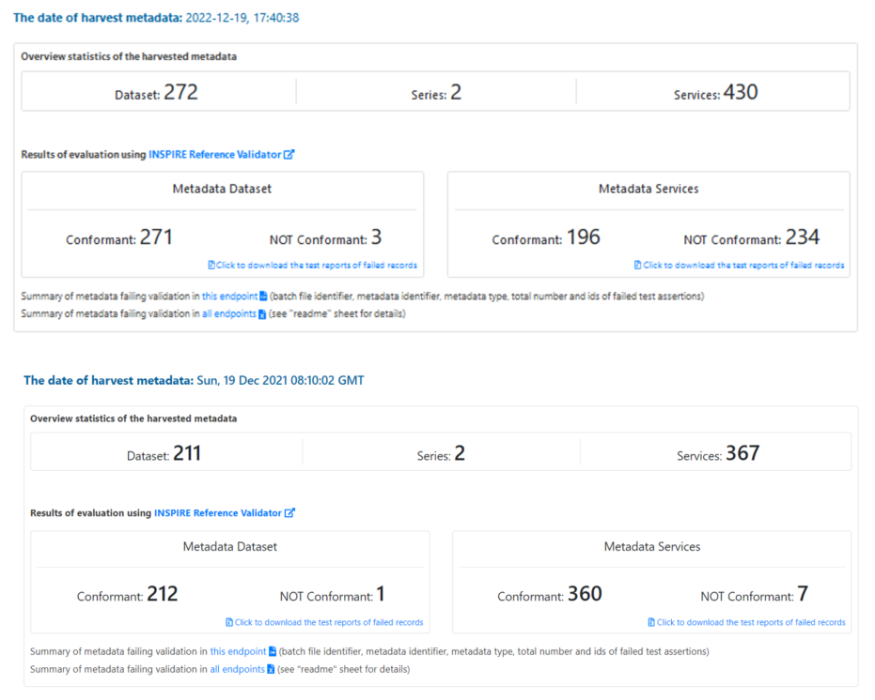
Figure 1: Overall metadata availability and conformity comparison (Source INSPIRE Monitoring and Reporting 2021, 2022)
- Comparing overall availability and conformity status there are no significant changes, aside reduction of the performance in accessibility of the spatial data sets through view and download.
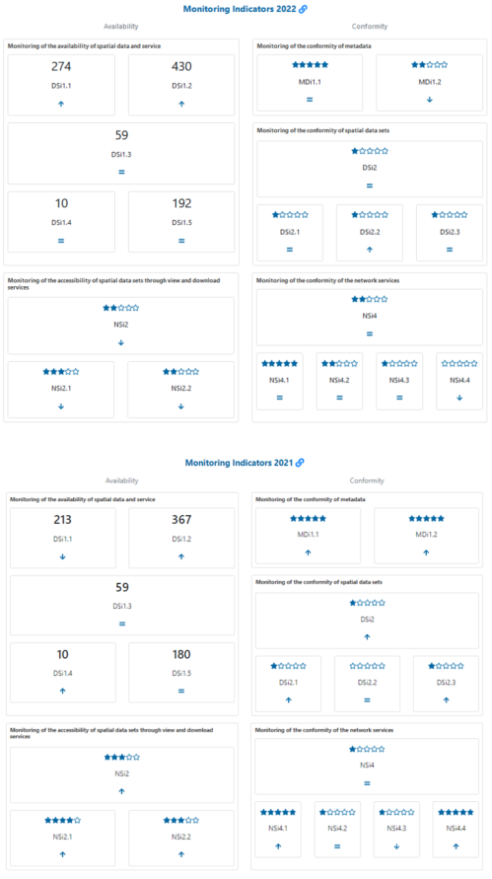
Figure 2: SK INSPIRE monitoring indicators 2021/2022 (Source Source INSPIRE Monitoring and Reporting 2021, 2022)

- In connection to the issue with filtering of Non – INSPIRE and AsIs INSPIRE datasets, reported in last 2021 report, even this year it was not possible to apply the intended filter, because of changes on the central EC INSPIRE geoportal infrastructure.
- It is also difficult to investigate the reasons for reduction of some indicators, as there were issues with harvesting of the SK metadata to the EC Geoportal during the second half of 2022. At the same time, possible outages of national discovery service could take place in January 2023, when validation of the metadata took place as communicated with EC.
- From the content point of view, it can be concluded, that by the end of the 2022 Slovakia has managed:
  - To provide data and services, documented with metadata for 26 INSPIRE themes
  - Similarly identify and share 30 INSPIRE priority datasets
- In order to strengthen the support for INSPIRE validation, SK national instance of INSPIRE refrerence validator has been deployed.
- Additional information/communication channels:
  - inspire.gov.sk Facebook Page
  - INSPIRE INFO Newsletter sharing related updates on monthly basis.
  - Inspire.gov.sk YouTube channel providing video recordings from meetings, conferences, workshops, trainings and other related events.
  - GitLab project representing collaboration platform for spatial data and service providers as well as users

1.3 Usage of the infrastructure for spatial information
- There is available only limited type of quantifiable evidence of the infrastructure use from Google analytics statistics related to the INSPIRE related websites for 2022:
  - geoportal.gov.sk: 11 892 users, 22 575 relations, 60 318 pageviews;
  - rpi.gov.sk: 1 907 users, 3 848 relations, 6 413 pageviews;
  - inspire.gov.sk: 1862 users, 4 117 relations, 5 647 pageviews.
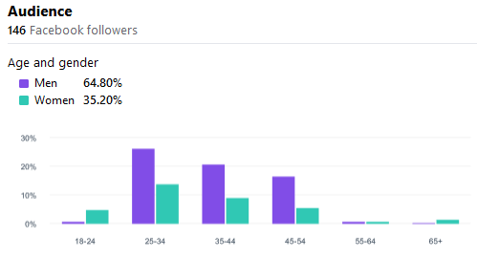
Figure 5: inspire.gov.sk Facebook page audience (Source: https://www.facebook.com/inspiresk)

- New outcomes from the User perspective interaction collected during Tatra workshop 2022.
- Set of pilot use cases has been also supported by the ESPUS project.
- There is significant gap also on EU level with guidance, how to systematically monitor infrastructure usage in comparative way across the Europe.
- Monitoring of the selected INSPIRE sevices is foreseen in order to increase and overview about their availability.
- New concept of metadata for applications might also provide an input to the usage measurement.

1.4 Data Sharing Arrangements
- Adoption of HVD regulation initiated discussion about the geospatial datasets to be made available under Open Data license and in synergy with INSPIRE.
- SK deed versions of Creative commons licenses were published from creativecommons.org with the support from ESPUS project.
- In connection to update of the Spatial data registry, there are foreseen activities focused on revision of existing dataset metadata records to ensure proper license citation to support better Open data filtering.
- Based on the further EU guidance for HVD, as well as developments on National open data portal managed by the the Ministry of Investments, Regional Development and Informatization of the Slovak Republic, further activities on integration of the open spatial data will take place.

1.5 Costs and Benefits
- The cost and benefits evaluation is based on the information collected in the structured tabular information from the representatives of the NSDI council.
- The total indicative costs related with the INSPIRE implementation: 1 056 487 € and 397 person days.
- From the Benefits perspective, these were identified mainly as:
  - Uniform access to spatial data (priority/harmonized datasets)
  - More efficient management and functionality of internal spatial data and services
  - Elimination of duplication of spatial data sharing in synergy with Open data and HVD
  - Developing pressure to identify the benefits and potential of using spatial data
  - Improving the availability of spatial data
  - Support for reuse
  - Strengthening communication with external domains and communities
  - Increasing pressure on machine delivery of digital data
  - Improving the provision of information on the environment not only for the needs of EU monitoring and reporting
  - Increasing pressure on the quality of spatial data and services and their documentation with metadata
  - Analytical use (environment, healthcare and other areas)
  - Raising awareness of the potential of spatial data and services
  - ensuring the availability of forest data to a wide range of users without restrictions
  - processing requests for the provision of data through services
  - Published metadata and spatial data services
Published datasets
- Detailed information about the costs and benefits can be accessed via this summary table. Details, based on the information provided by the organisations.

https://inspire.gov.sk/projekty/espus
https://inspire.gov.sk/podujatia/historia#Konferencie
https://inspire.gov.sk/podujatia/historia#Workshopy
https://inspire.gov.sk/podujatia/historia#%C5%A0kolenia
https://inspire-geoportal.ec.europa.eu/mr2021_details.html?country=sk&fbclid=IwAR03rU-LYD9YKivMxXjbkBpotyVoJwuju54PQqqxehLHLo-t1KZwh5CiTf4
https://inspire-geoportal.ec.europa.eu/mr2022_details.html?country=sk&fbclid=IwAR03rU-LYD9YKivMxXjbkBpotyVoJwuju54PQqqxehLHLo-t1KZwh5CiTf4
https://inspire-geoportal.ec.europa.eu/results.html?country=sk&view=details&theme=none
https://inspire-geoportal.ec.europa.eu/results.html?country=sk&view=details&legislation=all
https://validator.inspire.stage.geocloud.sk
https://inspire.gov.sk/clanok/388
https://inspire.gov.sk/zdielanie/vzory-dohod

